|  |  |  |
| --- | --- | --- |
| Day of the Week: | Assignments: | Notes: |
| MONDAY | Reading  Reading Log  Fast Math – 1 minute   * Complete * Incomplete |  |
| TUESDAY | Informational Text  Reading Log  Fast Math – 1 minute   * Complete * Incomplete |  |
| WEDNESDAY | Writing  Reading Log  Fast Math – 1 minute   * Complete * Incomplete |  |
| THURSDAY | Math  Reading Log  Fast Math – 1 minute   * Complete * Incomplete |  |
| FRIDAY/ SAT & SUN | Math  Reading Log  Fast Math – 1 minute   * Complete * Incomplete |  |

**Reading Log September 15-September 21**

**Directions**: Each day, scholars must spend thirty minutes reading independently. Please write down the title of the book, the number of pages read, and the genre of the book. Finally, sign your initials. ***Instrucciones****: Cada día, los académicos deben pasar treinta minutos de lectura independiente. Por favor escriba el título del libro, el número de páginas leídas, y el género del libro. Finalmente, firme con sus iniciales.*

|  |  |  |  |
| --- | --- | --- | --- |
| **Date**  *Fecha* | **Book Titles & Pages Read**  *Títulos del Libros* | **What Genre?**  ¿*Qué género?* | **Parent Initials**  *Iniciales del Padre* |
| **Mon.**  **Sept. 15** |  |  |  |
| **Tues.**  **Sept. 16** |  |  |  |
| **Wed.**  **Sept. 17** |  |  |  |
| **Thurs.**  **Sept. 18** |  |  |  |
| **Fri.**  **Sept. 19** |  |  |  |
| **Sat.**  **Sept. 20** |  |  |  |
| **Sun.**  **Sept. 21** |  |  |  |

**Daily Fast Math 1 Minute Drill**

**Directions:** On Monday, do as many problems as you can in one minute. Then circle the problem you left off on in red. On Tuesday start at the red and time yourself for one minute again. Circle the last completed problem in blue. On Wednesday start at the blue and time yourself for one minute. Circle the last completed problem in green. *Instrucciones: Toma el tiempo para ver cuantos problemas puedes completar en un minute. Circula con rojo el problema en el que te quedaste. El martes comienza con el problema en rojo y toma el tiempo por un minuto. Circula el último problema completado en azul. El miércoles comienza con el problema en azul y toma el tiempo por un minuto. Circula el último problema completado en verde.*



**Daily Fast Math 1 Minute Drill**

**Directions:** On Thursday, do as many problems as you can in one minute. Then circle the problem you left off on in red. On Friday start at the red and time yourself for one minute again. Circle the last completed problem in blue. On Saturday start at the blue and time yourself for one minute. Circle the last completed problem in green. *Instrucciones: Toma el tiempo para ver cuantos problemas puedes completar en un minute. Circula con rojo el problema en el que te quedaste en* *jueves. En viernes comienza con el problema en rojo y toma el tiempo por un minuto. Circula el último problema completado en azul. El sábado comienza con el problema en azul y toma el tiempo por un minuto. Circula el último problema completado en verde.*



**Monday: Reading**

Name: Date:

**Directions:** Read the passage and answer the questions to make predictions about the story.

**The Sandwich Thief**

Mike was very hungry.

“I think I’ll make a sandwich,” he said. Mike went to his kitchen. He got two pieces of bread. He put turkey on his sandwich. He put cheese on his sandwich. Then he added lettuce and tomato.

____ 1. What will happen to the sandwich?

a. Mike will eat it.

b. Mike will put it in his lunch box.

c. Someone will take his sandwich.

d. Mike will feed it to his dog.

“Yum,” said Mike. He licked his lips. Then the doorbell rang.

_____ 2. What will happen next?

a. Mike will eat the sandwich.

b. Mike will answer the door.

c. Mike will take the sandwich to the door.

d. Mike will answer the phone.

Mike went to get it.

Mike’s dog, Max, walked into the kitchen. Max sniffed the sandwich. The sandwich smelled good to Max. Max licked his lips.

_____ 3. The author adds a lot of details about the sandwich. Which of the following is not true about Mike's sandwich?

a. It has meat.

b. It has cheese.

c. It has vegetables.

d. It has mayonnaise.

_____ 4. This passage is

a. directions on how to make a sandwich.

b. a description of a sandwich thief.

c. a story about a sandwich thief.

d. none of the above.

_____ 5. What do you think will happen next in the story?

_______________________________________________________________

_______________________________________________________________

_______________________________________________________________

**Tuesday: Informational Text**

**Directions:** Read the passage and answer the questions.

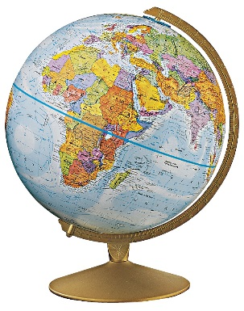**Celebrations around the World**

Let’s Celebrate! Countries around the world take part in different celebrations throughout the year. The world map shows some of those countries.

**Peru: Festival of the Sun**

The Festival of the Sun in Peru takes place in June. That is the time of year when the sun is farthest away from Peru and daylight is shortest. The festival honors the sun.

**Bulgaria: Rose Harvest Festival**

The Rose Harvest Festival in Bulgaria takes place in June. People celebrate with folk music, dances, and traditional costumes. Many roses grow in Bulgaria. Those flowers are used to make products such as perfume and chocolate.

**Ghana and Nigeria: Yam Harvest**

The Yam Harvest Festival takes place each August. A **yam** is a vegetable that grows in some African countries. People in Ghana and Nigeria wear traditional costumes and carry yams to celebrate this holiday.

**Australia: History of Aboriginal Australians**

In July, people in some places in Australia celebrate the history of Aboriginal Australians. Aboriginal Australians are the native people of Australia. As part of the week-long celebration, people wear traditional costumes, paint their faces, and perform dances. One dance is called, “shake a leg.”

**China: Dragon Boat Festival**

The Dragon Boat Festival takes place in China each year in June. People in this country take part in boat races. The boats are decorated to look like dragons, a Chinese symbol of luck. The festival celebrates good luck for the next year.

**United States: Independence Day**

Independence Day takes place on July 4. It is the day the United States celebrates its freedom from British rule. People often wear the colors of the American flag, march in parades, and watch fireworks to celebrate this holiday.

**“Celebrations Around the World” Questions**

_____ 1. Which celebrations include dressing up in traditional costumes?

a. Festival of the Sun, Independence Day and Yam Harvest

b. Rose Harvest, Yam Harvest and History of Aboriginal Australians

c. Rose Harvest, Dragon Boat Festival and Independence Day

d. Festival of the Sun, Rose Harvest and Dragon Boat Festival

_____ 2. Which celebrations include dancing?

a. Festival of the Sun and Independence Day

b. Yam Harvest and Dragon Boat Festival

c. Rose Harvest and Yam Harvest

d. Rose Harvest and History of Aboriginal Australians

_____ 3. The author included a map in the article to

a. show where the celebrations take place.

b. teach about the seven continents.

c. provide the reader with a pretty picture.

d. give the reader more information about the dances.

_____ 4. What do all of these festivals have in common?

a. They all have folk dancing.

b. They all take place during the summer months.

c. They all celebrate a harvest.

d. All of the above.

5. How are the Yam Harvest and the Rose Festival similar, and how are they different?

_______________________________________________________________

_______________________________________________________________

_______________________________________________________________

**Wednesday: Writing**

**Directions:** Answer the following writing prompt in 2-3 paragraphs. (Remember: a paragraph has 5-7 sentences)

**Imagine you had a pen pal (a friend you write letters to because they live in a different place than you). Your pen pal lives in one of the places that you read about in last night’s Celebrations around the World homework. What would you ask them about their country’s celebrations? What would you like them to know about the celebrations we have for July 4th in the United States? What do you find most interesting or exciting about their celebrations?**

Dear Pen pal,

**_______________________________________________________________**

**_______________________________________________________________**

**_______________________________________________________________**

**_______________________________________________________________**

**_______________________________________________________________**

**_______________________________________________________________**

**_______________________________________________________________**

**_______________________________________________________________**

**_______________________________________________________________**

**_______________________________________________________________**

**_______________________________________________________________**

**_______________________________________________________________**

**_______________________________________________________________**

**_______________________________________________________________**

**_______________________________________________________________**

**_______________________________________________________________**

**_______________________________________________________________**

**_______________________________________________________________**

**_______________________________________________________________**

**_______________________________________________________________**

**_______________________________________________________________**

**_______________________________________________________________**

**_______________________________________________________________**

**_______________________________________________________________**

**_______________________________________________________________**

**_______________________________________________________________**

**_______________________________________________________________**

**_______________________________________________________________**

**_______________________________________________________________**

**_______________________________________________________________**

**_______________________________________________________________**

**_______________________________________________________________**

**_______________________________________________________________**

**_______________________________________________________________**

**_______________________________________________________________**

**_______________________________________________________________**

**_______________________________________________________________**

**_______________________________________________________________**

**_______________________________________________________________**

**_______________________________________________________________**

**_______________________________________________________________**

**_______________________________________________________________**

**_______________________________________________________________**

**_______________________________________________________________**

**_______________________________________________________________**

**_______________________________________________________________**

Your friend,

**_______________________________**

**Thursday: Math**

**Directions:** Fill in the missing numbers and write the skip counting pattern.

1. 24, 34, 44, 54, _________, __________, 84, 94

The pattern is skip counting by __________________________

2. 15, 20, 25, 30, 35, __________, 45, 50, _________, 60

The pattern is skip counting by__________________________

3. 338, 348, 358, _________, __________

The pattern is skip counting by_____________________

4. 274, 374, __________, 574, 674, __________

The pattern is skip counting by ____________________

5. _________, __________, 75, 65, 55, 45

The pattern is skip counting by ________________________

6. 44, 54, 64, 74, _________, __________, 104, 114

The pattern is skip counting by __________________________

7. 115, 120, 125, 130, 135, __________, 145, 150, _________, 160

The pattern is skip counting by__________________________

8. 559, 659, 759, _________, __________

The pattern is skip counting by_____________________

9. 108, 208, __________, 408, 508, __________

The pattern is skip counting by ____________________

10. _________, __________, 82, 72, 62

The pattern is skip counting by ________________________

**Friday-Sunday: Math**

**Directions:** Use the number in the box to answer the questions below.

|  |
| --- |
| 1,375 |

1. Draw the number using base ten blocks.

|  |
| --- |
|  |

1. What digit is in the tens place? _____________________
2. What digit is in the ones place? _____________________
3. What is the value of the digit in the hundreds place? _________________
4. What is the value of the digit in the tens place? ____________________
5. What digit is in the hundreds place? _______________________
6. What is the value of the digit in the ones place? ________________
7. What digit is in the thousands place? _______________________
8. What is the value of the digit in the thousands place? ____________
9. What number is represented by the base ten blocks **below**? ______________

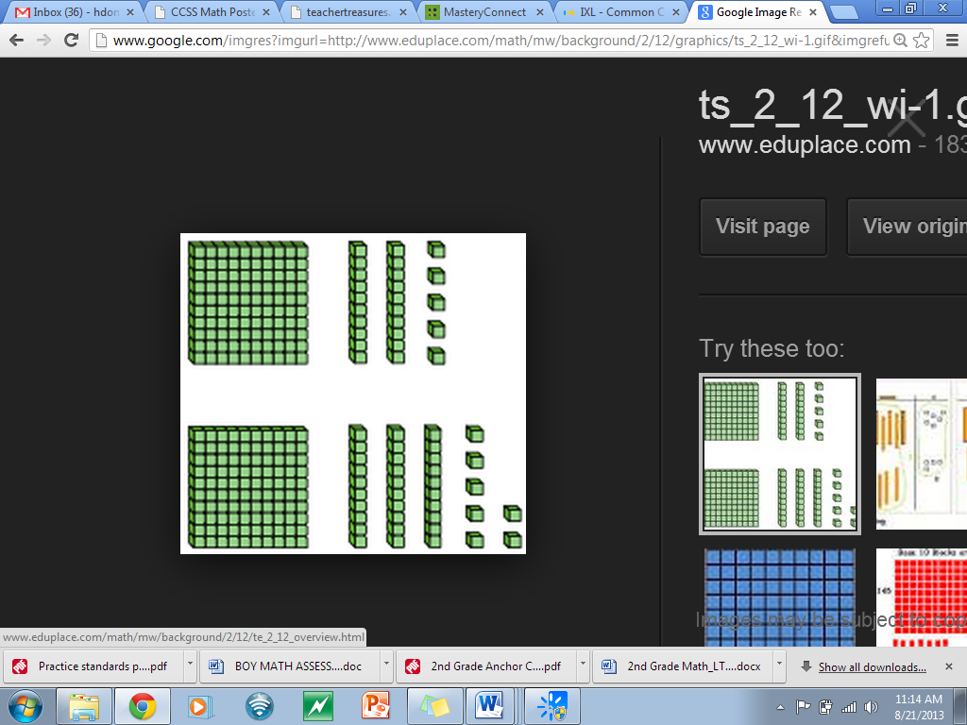

**Directions:** Use the number in the box to answer the questions below.

|  |
| --- |
| 483 |

1. Write this number in expanded form

|  |
| --- |
|  |

1. Write this number in written form

|  |
| --- |
|  |

1. Is this number odd or even?

|  |
| --- |
|  |

1. Compare the numbers 483 and 438.

|  |
| --- |
|  |

1. What is 10 more than this number? ____________________
2. What is 10 less than this number? ______________________
3. What is 100 more than this number? ____________________
4. What is 100 less than this number? ______________________